World Arts Film Festival e-Voting and Feedback System
Vision

Version 2.3

Revision History
Date | Version | Description | Author
09/24/15 | 1.0 | Initial Project Vision | John Verdi and Timothy Folds (Sections 4.1 and 4.2
10/18/15 | 2.0 | Adjusted document to better reflect event and actors | John Verdi
10/19/15 | 2.1 | Changed all instances of “website” to “web application” and added the system context diagram | Timothy Folds
10/20/15 | 2.2 | Finished final deliverable 2 review, many cosmetic changes | John Verdi
10/23/2015 | 2.3 | Added an appropriate scope (1.2) | Timothy Folds

Table of Contents
1. Introduction 4
1.1 Purpose 4
1.2 Scope 4
1.3 Definitions, Acronyms, and Abbreviations 4
1.4 References 4
1.5 Overview 4
2. Positioning 4
2.1 Business Opportunity 4
2.2 Problem Statement 5
2.3 Product Position Statement 5
3. Stakeholder and User Descriptions 6
3.1 Market Demographics 6
3.2 Stakeholder Summary 6
3.3 User Summary 6
3.4 User Environment 7
3.5 Stakeholder Profiles 7
3.5.1 Community Partner 7
3.5.2 Codeachrome 7
3.5.3 Community Liaison 8
3.5.4 feature[23] 8
3.6 User Profiles 9
3.6.1 Voter 9
3.6.2 Administrator 9
3.7 Key Stakeholder or User Needs 10
3.8 Alternatives and Competition 10
4. Product Overview 10
4.1 Product Perspective 10
4.2 System Context Diagram 11
4.3 Summary of Capabilities 11
4.4 Assumptions and Dependencies 12
4.5 Cost and Pricing 12
4.6 Licensing and Installation 12

Vision

Introduction
World Arts Film Festival (WAFF) is a film and arts event program in Jacksonville, Florida serving all ages and abilities, including those with special needs. The annual three-day festival screens over 100 short independent films from around the world, while simultaneously producing educational panels, interactive workshops, receptions and awards. The e-Voting and Feedback System (EVFS) will provide a way for our community partner to gather votes for each screened movie within their assigned block, collect demographic information on voters and display a real-time leader board for festival attendees.

Purpose
This document seeks to gather, evaluate and define platform requirements for the EVFS and assess the requirements and resources needed for each stakeholder to bring the vision to fruition.

Scope

The scope of this project has two stand-alone parts to it, which are a web application and a mobile application. Both applications will adhere to the requirements set forth by the stakeholders and can be found in the following; Product vision, software development plan, user stories, and sprint backlog. The product will be completed by the end of the spring semester and will have several product releases before the final release.

Definitions, Acronyms, and Abbreviations
EVFS: e-Voting and Feedback System
WAFF: World Arts Film Festival

References
TBD

Overview
Table of Contents (See Page 2)

Positioning

Business Opportunity
The e-Voting and Feedback System (EVFS) has the potential to create an awards event like atmosphere amongst the stakeholders who submit films, and winning an award would validate their creative energy and could be used to enhance their reputation as an artist. This will help attract future participants to the event. Additionally, voluntary data collected on voters may be used to send invitations to future events and demographic information may be helpful when applying for grants and enticing sponsors.

Problem Statement
The problem of | providing a voting platform that treats each voter as a unique entity and allows one vote per block of films presented over a three day period
affects | Voters, Film makers and event organizer (client)
the impact of which is | the inability to provide feedback to the film makers and missing an opportunity to capture data on voters
a successful solution would be | A platform that captures needed data to uniquely identify voters, provides timely voting and feedback to film makers in the form of a leader board and allows event organizers to service attendees and not the system

Product Position Statement
For | voters, film makers and organizers of WAFF
Who | want to participate more fully in the event as a competition for film makers
The (EVFS) | is a software application
That | captures needed data to uniquely identify voters, provides timely voting and feedback to film makers in the form of a leader board and allows event organizers a way to manage the event and collect valuable data
Unlike | current manual system
Our product | will allow organizer to set up event schedule and collect both voter information and votes, store them electronically and automate processes such as tabulation of votes and recording of voter information previously done by hand

Stakeholder and User Descriptions

Market Demographics
World Arts Film Festival (WAFF) is a film and arts event program in Jacksonville, Florida serving all ages and abilities, including those with special needs. The annual three-day festival screens over 100 short independent films from around the world, while simultaneously producing educational panels, interactive workshops, receptions and awards. The event will typically host 300 to 400 attendees from diverse backgrounds. Attendees are typically working professionals with an interest in the arts

Stakeholder Summary
Name | Description | Responsibilities
Codeachrome | Represents the UNF student team primary responsible for development and implementation of application | Codeachrome will seek to design a solution for our community partner that is easily maintainable, provides the voting capability desired, while maintaining voter integrity, and collects vital data about voters
Community Liaison (Karthikeyan Umapathy) | The Boss | Provides overall leadership and acts as liaison between community partners and the UNF team
feature[23] | Has provided time and resources to Codeachrome to mentor them through the software development process | feature[23] provides key support to the team and a successful outcome would have positive ramifications for them in the community

User Summary
Name | Description | Responsibilities | Stakeholder
Administrator (Community Partner) | Manages system backend, has access to scheduling, voting information and attendee data | - Schedules event  - Enters movie data  - Assigns movies to time blocks  - Generates voting and demographic reports | Karen Sadler
Voters | Utilize system to vote on one movie in each time block during festival. Are asked to provide demographic and contact information | - Login using unique voter ID card  - Screen movies  - Vote on movies by time block  - Provide contact and demographic (if willing) | Many

User Environment
The World Art Film Festival is an indoor event with approximately 300 to 400 attendees. The EVFS will be deployed at voting kiosks throughout the venue and via a mobile application. The system will be web based and mobile compatible.

Stakeholder Profiles

Community Partner
Representative | Karen Sadler
Description | Business community partner
Type | will be system administrator
Responsibilities | - Schedules event  - Enters movie data  - Assigns movies to time blocks  - Generates voting and demographic reports
Success Criteria | Simplifies event planning, data collection, voting and administration
Involvement | Provides product guidance and desired features
Deliverables | Demographics reports, voters information, voting totals
Comments / Issues | System and features need to be simple to configure and use and satisfy customer expectations

Codeachrome
Representative | John Verdi, Julio Orozco, Timothy Folds, Donny Dedman, Jeremiah Doody
Description | Development team
Type | System Experts
Responsibilities | - Design and implement EVFS  - Ensure Community Partner's needs are met  - Provide documentation
Success Criteria | Functioning user-friendly system that address Community Partner's needs
Involvement | Collect user requirements, create stories and design solution
Deliverables | Team Contract, Team Contact Sheet, Project Vision, Software Development Plan, Documentation for applications, Application, Mobile Application
Comments / Issues | A successful product requires a clear understanding of the Community Partner's needs

Community Liaison
Representative | Karthikeyan Umapathy
Description | Program creator
Type | Professor and Process Expert
Responsibilities | - Provides tools for success  - Ensures resources are available  - Keeps teams on track  - Provides conflict resolution
Success Criteria | Teams have resources to be successful in meeting project goals
Involvement | Provides guidance and support
Deliverables | Successful Symposium
Comments / Issues

feature[23]
Representative | Nick Campanini and Mike Potts
Description | Professional Mentor
Type | Subject Matter Experts
Responsibilities | - Provides training and support  - Shares real-world experience  - Provides supplemental training  - Helps keep project on course
Success Criteria | Having mentored team meet success criteria
Involvement | Providing weekly meetings and constant availability for guidance and brain storming of problems
Deliverables | Guidance, knowledge and support
Comments / Issues | Key to bridging academic environment and real-world

User Profiles

Voter
Representative | WAFF Voters
Description | Art Film Festival Attendee
Type | user
Responsibilities | - Login to system using unique voter ID card  - Provide information  - Vote
Success Criteria | No recollection of technology use at festival
Involvement | Uses system features
Deliverables | Voters contact data, demographics and votes
Comments / Issues | System must accommodate wide range of technical competencies

Administrator
Representative | Karen Sadler
Description | Business community partner
Type | will be system administrator
Responsibilities | - Schedules event  - Enters movie data  - Assigns movies to time blocks  - Generates voting and demographic reports
Success Criteria | Simplifies event planning, data collection, voting and administration
Involvement | Provides product guidance and desired features
Deliverables | Demographics reports, voter information, voting totals
Comments / Issues | System and features need to be simple to configure and use and satisfy customer expectations

Key Stakeholder or User Needs
Need | Priority | Concerns | Current Solution | Proposed Solutions
Create time constrained voting solution | High | Ensuring unique voter and one vote per time slot | Manual paper system or none at all |  | Online web based application and mobile application
Collect voter contact and demographic data | High | Not all Voters will provide data | None |  | Prompt voters on login to provide email and answer four relevant demographic questions
Create database to populate movies into scheduled time slots for event | High | Administration needs to be user-friendly | Spreadsheet |  | Create scheduling system with user interface to easily manage scheduling
Create database to store collected demographic and contact information | High | Administrator needs simple interface to pull reports and create mailings | Spreadsheet, email |  | Create custom solution for reports and look into email list APIs for managing mailing lists and contact information.
Community Partner would like to consolidate design elements | Medium | Difficulty getting preferences during run up to event | None |  | Create design attribute sheet for community partner while developing CSS.

Alternatives and Competition
No off-the-shelf solution fits our stakeholder requirements necessitating a custom coded solution

Product Overview

Product Perspective
The current proposed solution is to have a server for EVFS that will contain a database (TBD) and the website itself. The database will contain information used by both the website and mobile app. Other than the database, the website and mobile app are independent products. The website deals with the administrative side and voters who are voting via kiosk. The mobile app deals with voters who wish to download the app to vote and will be available on multiple platforms.

System Context Diagram
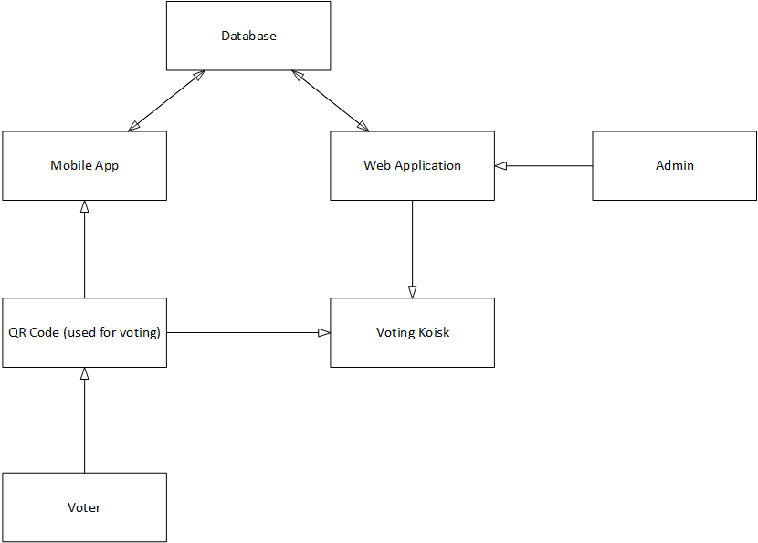

Summary of Capabilities
Table 4-1 Customer Support System
Customer Benefit | Supporting Features
EVFS voters can vote according to their preference. | Voters can vote using the mobile app or website (Kiosk).
EVFS voters can view leader boards | Leader boards will be displayed on the website in real time.
EVFS voters will be given a unique voter ID card as they enter event. | With voter ID card, voters can vote once per block. This system allows for 'walk-ins'.
EVFS voters can only vote once per block. | System will prevent users from voting more than once per block.
EVFS admin can manage films. | Admin can add/modify/delete films.
EVFS admin can manage time blocks. | Admin can add/modify/delete time blocks and add films to the time blocks and add films to
EVFS admin can view demographics. | Admin will have access to view any demographics collected during voting.

Assumptions and Dependencies
We are designing our application in a .NET environment.

Cost and Pricing
There is no charge for developing the software components of this project. There may be hardware costs the organization will need pay for in order to successfully implement the system. These costs will be associated with festival kiosks and the system used to uniquely identify voters.

Licensing and Installation
Codeachrome retains the rights to all created intellectual property and allows the World Arts Film Festival the use of our EVFS free of charge for their festivals.

